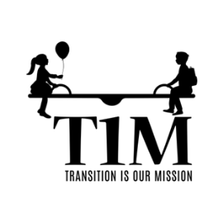
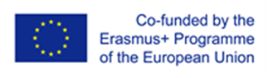

Transition Is our Mission
1st study visit, Croatia
8-10 December, 2021

This European project is about how to contribute smooth transition from kindergarten to school.Kindergarten „Sisak Novi“ and elementary school „Braća Bobetko“ cooperate in the project.8-10 December 2021,was the 1st study visit in Croatia. Our partners in the project from Latvia and Slovenia visitied us for three days. We exchanged experiences and spent time useful to the satisfaction of everyone. The first two days presentations were held inelementary school “Braća Bobetko” and the other one in kindergarten “Sisak Novi”.

Schedule,titles of the presentations and activities:

FIRST DAY- Location: Elementary School Braća Bobetko
-Getting to know each other, presentation of the elementary school and the kindergarten, Bagpack
activity – contributions, fears, expectations
-Croatia – national research and reccommendations; Identifying most common issues in all three
countries Reflection on the PLCs – transitional practices implemented throught the programme on the example of Croatia
-Reflection on the PLCs – transitional practices implemented throught the programme on the example of Croatia
-visit to the Holland House

SECOND DAY- Location: Elementary School Braća Bobetko
- Observation of the school's practice using video clips + reflectio
-Supporting children from vulnerable backgrounds during the period of transition – obstacles and ways forward
- Examples of successful transition practices - Getting ready for school programme
- Examples of successful transition practices –Play Hub
-Golden Piroutte

THIRD DAY- Kindergarden DV Sisak Novi, branch kindergarden Sunce

-Observation of the kidnergarten's practice using video clips + reflection
- COVID-19 and it's impact on softening the transition
- Takeaway messages and planning of the transitional practices
- Evaluation

